MEMORANDUM |  |  | CITY OF PHILADELPHIA
 |  |  | CIVIL SERVICE COMMISSION
 |  |  | DATE:
TO: | James Leonard, Records Commissioner
FROM: | Civil Service Commission
SUBJECT: | Amendments of Civil Service Regulations

Basis:

The Civil Service Commission held a public hearing on February 20, 2020, to consider objections concerning Civil Service Regulations originally approved by the Commission on December 18, 2019.

In compliance with Section 8-407 of the Home Rule Charter, the Commission is submitting this report of the hearing to the Records Department. The following is a description of the events and processes leading to the hearing.

December 18, 2019:

The Office of Human Resources proposed amendments to the Civil Service Regulations at a public hearing, regarding Disability Accommodations, including the following: establishment of 10.01-5, amendment of 11.02-3, establishment of 11.02-3-1, amendment of 11.02311 (renumbered 11.02-3-1-2), establishment of 11.02-4, amendment of 11.024 (renumbered 11.02-5), amendment of 11.025 (renumbered 11.02-6), amendment of 14.01, amendment of 17.07, amendment of 17.07-1, 17.07-2 and 17.07-3, abolition of 17.0731 and 17.0732, amendment of 17.0734 ( renumbered 17.07-3-2), and establishment of Section 34, et al. The Commission approved the amendments.

January 10, 2020:

The Interim Director of the Office of Human Resources presented to the Administrative Board the above Regulation amendments approved by the Civil Service Commission on December 18, 2019. The presentation was made at a public meeting of the Administrative Board. The Administrative Board approved the Regulation amendments that had been presented.

The Office of Human Resources delivered the Regulations to the Department of Records. The Department of Records made the Regulations available for a thirty (30) day period of public inspection.

January 21, 2020:

The Civil Service Commission received a memo, dated January 17, 2020, from Lynda Yerkov, Records Operations Manager, Department of Records, stating that Catherine Scott, on behalf of AFSCME District Council 47 and the member of Locals 2187 and 2186, requests a hearing on the above Amendments of Civil Service Regulations, along with a copy of the email hearing request from Ms. Scott.

February 12, 2020:

The Civil Service Commission sent written notification via First Class Mail to Catherine Scott, informing her that the hearing requested would be held on Thursday, February 20, 2020, at 10:00 a.m., in Conference Room Z, 16th Floor, Municipal Services Building. A copy of the notification was also sent via First Class Mail to Union representatives of District Council 47 Robert Coyle, April Gigetts, Pamela Robinson and Dennis Gibson.

February 20, 2020:

The Civil Service Commission held a public hearing and the above-cited Regulations were presented.

Catherine Scott, President of District Council 47 (the “Union”), presented their objections to the Commission. Ms. Scott stated that District Council 47 directed a letter to Ms. Monica Marchetti-Brock, Director of the Mayor’s Office of Labor Relations, in which the Union outlined its objections. Ms. Scott stated that the City failed to address the objections by only making minor and stylistic changes to the gender language in the proposed regulations to make it more gender neutral but did not address the substance of their objections.

Ms. Scott presented the following objections to the existing regulations and suggestions for revision:
- 34.05 – A 10-day response time was suggested to be added to the regulation consistent with FMLA and the determination by the appointing authority to be specified.
- 34.06-1 – The “format prescribed by the Director” is not specific enough. The request was made for specific language around the format for transparency of an objective process by which to pursue the request. In addition, Ms. Scott suggested language be added consistent with examinations in accordance with 9.018.”
- 34.06-2 – There is no mention of a vocational counselor and should be explicitly stated if the counselor is part of the process.
- 34.06-3 – This section of the regulation refers to Regulations 11.02 and 11.03, which outline the Rule of 2 for certification from the eligible list. This selection process makes it possible that an employee can never be selected from the Accommodations list. The Union suggests that the Rule of 2 shall not apply to accommodations, similar to the Layoff List.
- 34.07-2- Revise the language to read that an employee who has exhausted all leave “shall be entitled” to an unpaid leave of absence rather than “may request” an unpaid leave of absence.
- Regulation 10 – The Accommodations list shall prevail over the promotional eligible list, similar to the Layoff List.
- Regulation 11 – Certifications from an Accommodations list shall take precedent over the promotional eligible list based on the time sensitive nature of the Accommodations list of one year compared to the two-year life span of the promotional eligible list. Accommodations should not be subject to the Rule of 2 because an employee on the list can be rejected (2x’d) and removed from the list when paired with an eligible employee from a promotional eligible list (per 11.02-3-1).
- 17.07-3 – Remove “and their appointing authority has denied any requests for additional unpaid leave” and change to “the employee has been granted a one-year leave of absence”.

For the City, Christopher Rider, Divisional Deputy City Solicitor, Labor and Employment Group, City of Philadelphia Law Department, presented the following response to the Union’s objections:
- The history of the Americans with Disabilities Act and its requirement to make accommodations for employees with disabilities. Accommodations can range from minor provisions by the employer such as supplies to larger accommodations such as reorganizing work functions.
- The goal of Regulation 34 is for compliance with the ADA by the City while preserving the Civil Service process. The City as an employer faces challenges because of the individual hiring authority that resides within departments.
- No timeframe is recommended for the department. Regulation 34 is triggered only when the department cannot accommodate. Regulation should not spell out specifically what the department must do. Rather, the regulation should describe the interactive process. The interactive process can be informal; it is not required by the ADA.
- Regulation 34 is not intended to govern the departmental timeframe. The interactive process is a collaborative process that may involve relevant parties and agencies. Regulation 34.05 should not state the “appointing authority”, the determination should not be assigned to one person if the department cannot accommodate.
- The format as prescribed by the Director is sufficient language to comply with the ADA. No specific format is required by the ADA.
- The Accommodations list does not require a formal examination process. No need to outline specifically the exam will occur in accordance with Regulation 9.018. The Regulation allows for whatever assessment is needed – an assessment of skills and physical abilities. An examination, in a traditional sense, limits the ability of the City to assess.
- The goal of the placement process is not to have the employee decline. The goal is to set the employee up for success, keep people working and keep the employee, if in a union-represented position, as a due paying member. The goal is to use the City’s existing human capital for a job that employees want to do and can do successfully.
- The Rule of 2 - The goal of the Accommodations list is not to kick people off of the list. If the department is not interested in appointing the employee, they are not to be taken off of the list. The employee can be certified out to other departments if the current hiring department is not interested. Giving departments a choice, selection, invests the department in the employee they select from Rule of 2. The Rule is stated in the Home Rule Charter and consistent with selection from other lists.
- For the leave of absence, enshrining one year of leave of absence is not in the City’s interest. The regulation is pro-employees, not to entitle one year without leaving room for discussion between the department, OHR, Risk, and other interested agencies.
- Regulation 17 – the process outlined is not for service-connected disability. It is for Regulation 34 and applies when the employee is unwilling to accept reassignment under Regulation 34, not Regulation 32.
- Departments should be able to promote from within and appoint from the promotional list. The City is willing to consider Ms. Scott’s points on where Accommodations List falls in order of lists as specified in Regulation 11.

For the City, Michael Zaccagni, Interim Director of the Office of Human Resources stated the following:
- Right now, there is no process in place for employees who experience a non-service-connected disability. Right now, those employees are separated from City service.
- The discretionary part of the department to promote an employee from a promotional eligible list before the Accommodations list should be sustained but still create an opportunity for the employee that currently does not exist.
- Regulation 34 provides a structure, a regulation, to provide for reassignment following a non-service-connected disability.

For the Union, Cathy Scott, President of District Council 47 responded to the City:
- The Union recognizes the improvement of the regulation over the current situation.
- The Union objects as they are not clear on why the City is not putting into the regulation that the appointing authority is the ultimate authority. Nicole Morris, Chief Deputy City Solicitor for Litigation, Labor and Employment Group, City of Philadelphia Law Department, stated that the position of the City is that the appointing authority is the ultimate authority.
- Accommodations list is only good for one year as opposed to two years for promotional lists. Should be incorporated into the regulations what the intent is for an employee matched with someone the department wants to promote from a promotional eligible list. Right now, as stated in 11.02-3-1, the employee can be paired with an eligible from a promotional list. Then the employee can be 2x’d. The union requests that the employee not be paired with promotional eligible lists.
- The Union requests an improved version of the regulations.

Commissioner Leonard Cid, Civil Service Commission, asked:
- If the employee declines, does that work against him? Once placed on the eligible list, is the employee expected to accept? Not with an unlimited opportunity to refuse any assignment.
- Does the regulation allow the employee to continue as a member paying union dues and receiving medical benefits and coverage through an employer?
Catherine Scott, President, District Council 47, offered a final response that departments currently grant leaves of absence to employees.

Conclusion:

After hearing all the objections and arguments, the Civil Service Commission re-affirms its approval of the following Regulations initially approved on December 18, 2019:

Regulation 10 - ELIGIBLE LISTS
Amendments under Section 10.01, TYPE OF LIST, including addition of Section 10.01-5, ACCOMMODATIONS LIST
Regulation 14 – PROBATIONARY PERIOD
Amendment of Section 14.01, APPOINTMENTS FROM ELIGIBLE LISTS
Regulation 17 – DISMISSALS, DEMOTIONS, SUSPENSIONS AND APPEALS
Amendment of Section 17.07, SEPARATION DUE TO NON-SERVICE INCURRED DISABILITY and Sub-sections
Section 34.08, APPOINTMENT FROM THE ACCOMMODATIONS LIST and Sub-Sections
Section 34.09, ACCOMMODATION POSITION PROBATIONARY PERIOD and Sub-Sections
Section 34.09, ACCOMMODATION POSITION PROBATIONARY PERIOD

AND modifies the following Regulations initially approved on December 18, 2019 as attached hereto:

Regulation 11 – REQUISITION, CERTIFICATION AND APPOINTMENT
Amendments under Section 11.02, LISTS USED FOR CERTIFICATION, including addition of Section 11.02-4, ACCOMMODATIONS LIST
Regulation 34 – DISABILITY ACCOMMODATIONS
Establishment of:
Section 34.04, REASONABLE ACCOMMODATION and Sub-Sections
Section 34.05, REASSIGNMENT AS A REASONABLE ACCOMMODATION
Section 34.06, ADA REASSIGNMENT PROCESS and Sub-Sections
Section 34.07, STATUS AWAITING REASSIGNMENT FROM AN ACCOMMODATION LIST and Sub-sections

/s/ Leonard Cid
__________________________________________ __10/7/20_____
Leonard V. Cid, Chair Date

/s/ Michael McAnally
_______________ _10/7/20____________
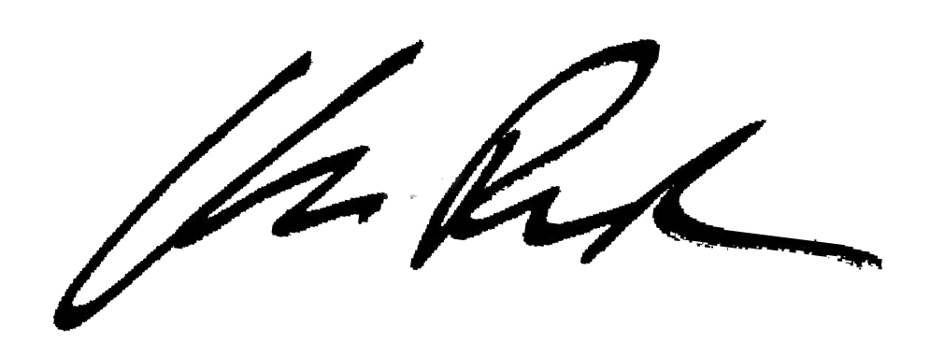
Michael McAnally, Commissioner Date

__________________________________________ 10/7/20
APPROVED – Law Department Date

